**Experiment No. 5**

**DIV: A** **Batch: A4**

**Team Members:**

**Name: SAP ID:**Dhruvi Jodhawat 60004190032

Harvy Gandhi 60004190043

Junaid Girkar 60004190057

**Aim:** Estimate effort and cost required using FP/COCOMO for the project. Create WBS and Gantt Chart for the same. Use the PM Tool to depict a project plan.

**Theory:**

**Work Breakdown Structure**:

### Work Breakdown Statement

A work breakdown statement (WBS) is a categorized list of tasks with an estimate of resources required to complete the task. An example WBS appears below.

| **WBS #** | **Task Description** | **Est Person -Hrs** | **Who** | **Resources** | **M&S** |
| --- | --- | --- | --- | --- | --- |
| 5.1 | Extract Data from Social Media sites | 168 | Researcher | Extrication Tools | $300 |
| 5.2 | Analyze the extracted data and detect patterns | 120 | Marketing Manager and Analyst | Excel, Tableau | $100 |
| 5.3 | Update the data for any inaccuracies | 48 | Local Authorities | Excel, Tableau | $100 |
| 5.4 | Testing the functionalities | 168 | Marketing Manager and Analyst | Testing Tools | $200 |
| 5.5 | Project Deployment | 72 | Marketing Manager and Analyst | Servers | $500 |
| 5.6 | Maintain data pipelines | 4320 | Marketing Manager and Analyst | Servers | $1000 |

(M&S = Materials & Supplies)

**Gantt Chart Basics**

Gantt charts are a project planning tool that can be used to represent the timing of tasks required to complete a project. Because Gantt charts are simple to understand and easy to construct, they are used by most project managers for all but the most complex projects.

In a Gantt chart, each task takes up one row. Dates run along the top in increments of days, weeks or months, depending on the total length of the project. The expected time for each task is represented by a horizontal bar whose left end marks the expected beginning of the task and whose right end marks the expected completion date. Tasks may run sequentially, in parallel or overlapping.

As the project progresses, the chart is updated by filling in the bars to a length proportional to the fraction of work that has been accomplished on the task. This way, one can get a quick reading of project progress by drawing a vertical line through the chart at the current date. Completed tasks lie to the left of the line and are completely filled in. Current tasks cross the line and are behind schedule if their filled-in section is to the left of the line and ahead of schedule if the filled-in section stops to the right of the line. Future tasks lie completely to the right of the line.

In constructing a Gantt chart, keep the tasks to a manageable number (no more than 15 or 20) so that the chart fits on a single page. More complex projects may require subordinate charts which detail the timing of all the subtasks which make up one of the main tasks. For team projects, it often helps to have an additional column containing numbers or initials which identify who on the team is responsible for the task.

Often the project has important events which you would like to appear on the project timeline, but which are not tasks. For example, you may wish to highlight when a prototype is complete or the date of a design review. You enter these on a Gantt chart as "milestone" events and mark them with a special symbol, often an upside-down triangle.

Gantt Chart Example from <http://www.criticaltools.com/projwbs.htm>

**Practical:**

**For Estimation**

1. Use the FP / COCOMO model to estimate Effort and subsequently Cost required to develop the project.
2. Show all the tables and steps of the estimation model.

Cost estimation

● E.I.: User Credentials, Local Authorities Credentials, Updation Data, Researcher Collected Data.

● E.O.: Location Details, Recommended Locations, Traffic Analysis

● E.Q.: Social Media Websites.

● I.L.F.: user datastore, location datastore, pre-processed datastore, recommender system

● E.I.F: -

| Information Domain Value | Count | Simple | Average | Complex | Total |
| --- | --- | --- | --- | --- | --- |
| External inputs | 4 | 3 | **4** | 8 | 4*4=16 |
| External Outputs | 3 | 4 | **6** | 9 | 6*3=18 |
| External enquiry | 1 | 2 | **3** | 6 | 3*1=3 |
| Internal Logical Files | 4 | 3 | **5** | 9 | 7*4=20 |
| External interface files | 0 | 4 | **7** | 10 | 7*0=0 |
|  |  |  |  | Count-total = 57 | |

The Fi (i = 1 to 14) are value adjustment factors (VAF) based on responses to the following questions:

**1. Does the system require reliable backup and recovery?**

○ 4 - It is essential to have reliable backup and recovery for important modules like transaction confirmation.

**2. Are specialized data communications required to transfer information to or from the application?**

○ 3 – Application needs to be “near-realtime” .

**3. Are there distributed processing functions?**

○ 1 - Yes

**4. Is performance critical?**

○ 4 - Performance is always critical

**5. Will the system run in an existing, heavily utilized operational environment?**

○ 5 - No, the project is not based on a pre-existing system.

**6. Does the system require online data entry?**

○ 4 - Yes

**7. Does the online data entry require the input transaction to be built over multiple screens or operations?**

○ 3 - Yes, updates of data by local authorities will be built over multiple screens.

**8. Are the ILFs updated online?**

○ 5

**9. Are the inputs, outputs, files, or inquiries complex?**

○ 3 - Yes

**10. Is the internal processing complex?**

○ 4 - Yes

**11. Is the code designed to be reusable?**

○ 4 - Yes as we are following the best coding practices.

**12. Are conversion and installation included in the design?**

○ 3

**13. Is the system designed for multiple installations in different organizations?**

○ 0 - No

**14. Is the application designed to facilitate change and ease of use by the user**

○ 4 - Yes

Σ(Fi) = 47

The estimated number of FP is derived:

FP(estimated) = count-total*[0.65 + 0.01*Σ(Fi)]

= 57*[0.65 + 0.01*47]

# = 63.84 function points.

**For WBS and Gantt Chart**

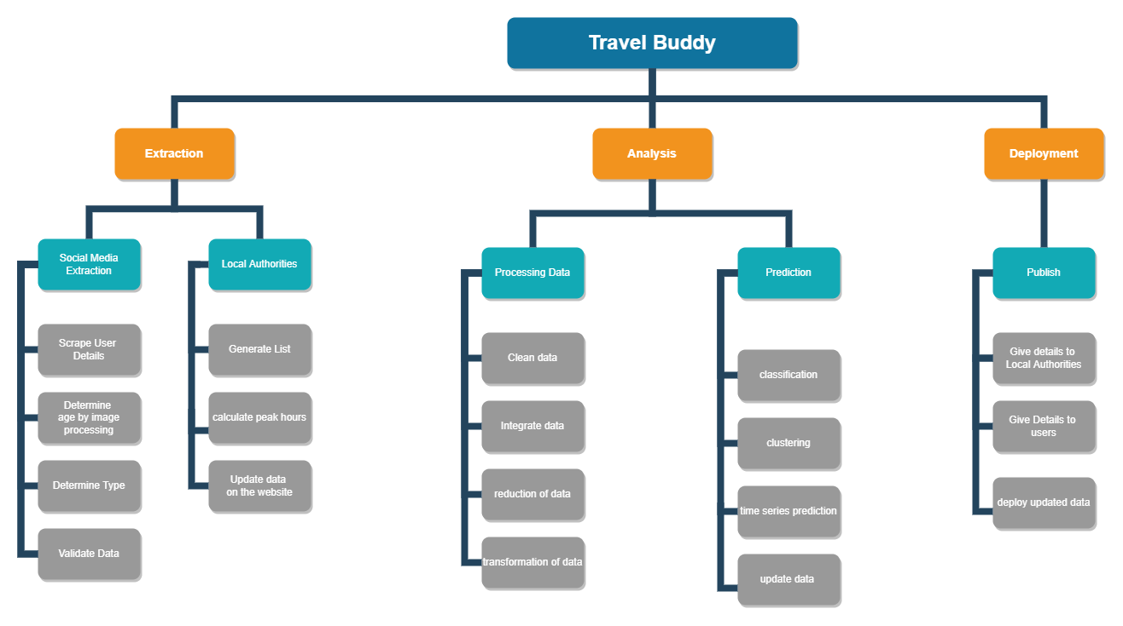

1. Create different tasks of your project depending on the process model that you have selected for the same.
2. Create a WBS or Task network diagram depicting clearly which tasks can happen in parallel and sequential.
3. Identify team members and allot them to the task
4. Based on the effort estimated in person months, distribute the effort on a 40-20-40 % basis.
5. Prepare a Gantt chart using any PM tool

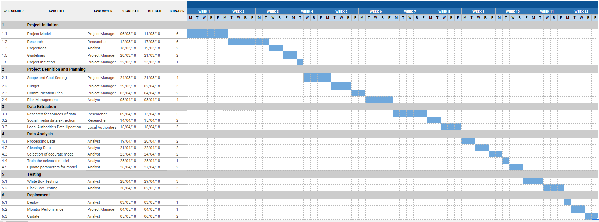

**Conclusion:**

Thus, we are able to estimate the effort required for our project and also create a Gantt Chart.